James A. Tuttle Library
The Next Chapter

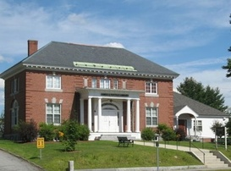

Strategic Plan
2021 - 2026

Table of Contents
Introduction …………………………………………………………………………………………………………………….3
Planning and Methodology ……………………………………………………………………………………………..4 Methodology ……………………………………………………………………………………………………….4
Needs Assessment ………………………………………………………………………………………………4
Acknowledgements …………………………………………………………………………………………………………5
Community Description …………………………………………………………………………………………………..6
Library ……………………………………………………………………………………………………………………………..7
History ………………………………………………………………………………………………………………….7
Governance ………………………………………………………………………………………………………….7
Support ………………………………………………………………………………………………………………..8
Description of Library Services ……………………………………………………………………………..8
Collection ……………………………………………………………………………………………………………..9
Circulation …………………………………………………………………………………………………………..10
Mission Statement ………………………………………………………………………………………………10
Survey and Conversation Results ……………………………………………………………………………….11-13
Survey …………………………………………………………………………………………………………….11-13
Comments ………………………………………………………………………………………………………11-13
Focus Group ………………………………………………………………………………………………………..14
Goals and Objectives ……………………………………………………………………………………………………….15
References ………………………………………………………………………………………………………………………16

Introduction:
The James A. Tuttle Library Board of Trustees, staff, and the community have engaged in the thought provoking and challenging task of creating a strategic plan for the library. The library has seen an increase in patronage, programming, and services in the last few years that we thought it would be in the interest of all to create a road map for the future. In 2016, the Antrim Community Profile was published and it is time to revisit what the community will need in the future from the library. It is our hope that our planning for the upcoming five years will address the community’s needs, as expressed through the focus groups and completed surveys.

Supporting funds came from Libraries Transforming Communities: Focus on Small and Rural Libraries an initiative of the American Libraries Association in collaboration with the Association for Rural and Small Libraries.

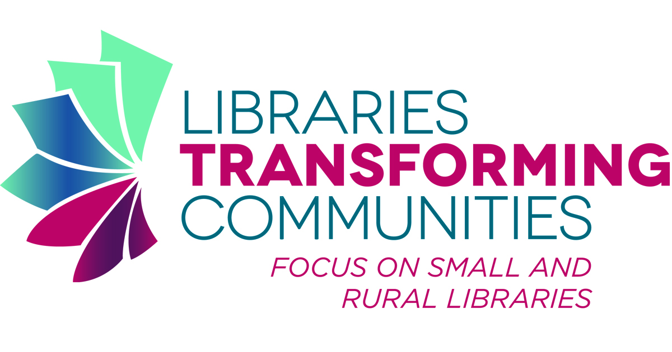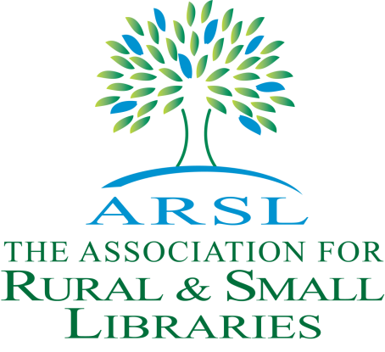

Methodology and Planning:
Methodology:
The Director worked in cooperation with the Trustees, the staff, and the public in the creation of this strategic plan. The process, loosely adapted from the Public Library Association's Planning for Results, calls for three meetings of the focus group and interim work by the Director and Trustees to compile the information gathered. Due to Covid-19 one small public meeting was held. Participants included members of the Library Trustees and staff, homeschooling families, and a cross-section of the community. In addition, an open response opinion survey requesting public input was sent out electronically through our newsletter, website, and Facebook. Visitors to the library also were encouraged to fill out and submit the survey on site. The results were tabulated and reviewed. Using this information, the director and trustees created the goals for the library for 2021-2026 together with objectives against which we will measure our progress.

Needs Assessment:
Input was collected from a community focus group and through a survey. The most requested items on the survey were more adult programs, children’s programs, and more museum passes. Additionally, there was a desire for the library to have more multigenerational events (family programs). Learning opportunities for increasing information literacy was another frequently requested topic. Responses indicated that a majority of respondents use the library for books and media, streaming media (including eBooks), and programs. Responses showed a preference for receiving library information electronically through social media, the town website, and the monthly email newsletter.

Acknowledgements:

Library Staff Library Trustees
Cindy Jewett, Library Director Rick Wood, Chair
Melissa Lawless, Assistant Director Diane Kendall, Treasurer
Laurie Cass-Griggs, Youth Services Susan Bartlett, Secretary
Ellen Neilly, ILL and Circulation Steve Ullman
Christopher Brinkley, Tech Nancy Blair

Community Description:
"The pride of a small town is mirrored in its celebrations... its parades and promenades."
In 1977 the Antrim History Committee wrote these words to introduce their history of Antrim's second hundred years. Those of us who know Antrim as home understand how true this statement is.
Antrim is a community with spirit. The people who live here work hard to make the town better in every way. This, in turn, draws others who are looking for a place to belong and build. Whether it's raising a new bandstand, building an elementary school playground, approving renovations to the Antrim Town Hall, or pitching in with photos for the new website, there are always many willing hands.
Though settled prior to the Revolution, Antrim was not incorporated until 1777. It was originally part of the Society Land, or Cumberland, named for the Duke of Cumberland, who was King George II's son and commander of English troops in the war with France. This large tract of land adjacent to Mount Monadnock had been set aside by the Portsmouth Proprietors for private estates. The land was later purchased by Philip Riley, who named the town for County Antrim in Ireland, his native home. Nathaniel Hawthorne College was established in Antrim in 1962; the school closed in 1988.
Villages and Place Names: Antrim Center, Clinton Village, Loverens Mill, North Branch
Population, Year of the First Census Taken: 528 residents in 1790
Antrim, NH currently has a population of approximately 2,600. The nearest city, Concord, the state capital with a population of 145,000 is 60 minutes away and Boston is approximately 90 minutes away.

Antrim has a Main Street dotted with small businesses, a library, a police department, and a brick town hall. The community of Antrim is an idyllic New England small town. Antrim has the two annual festivals each year Home and Harvest in September and the Festival of Trees in December. Both bring thousands of visitors to Antrim each year and are organized entirely by volunteers.

Library:
History:
In 1866 The Antrim Library Association was formed and the collection was kept in the front dining room in the Maplehurst Inn. The townspeople paid $1.50 a year to use the Library. In 1892 the town voted for the establishment of a free Library called the Antrim Free Library and the books were moved to the Antrim Town Hall. In 1905, James A. Tuttle, a lifelong resident of Antrim, left his estate to the town of Antrim for a library. Edwin R. Clark of Lowell, MA was selected as the architect of the library and it was built by James Whitlet. The library is a colonial revival style with a wooden double door in the front and a low-pitched hip roof. The walls are brick and the foundation is stone. On July 12, 1908 the Library was open to the public and Miss Sarah Adams was the first librarian. In 2007, the town voted to expand the library to include a children’s room, an area for a computer bank, and more stacks to accommodate the ever growing collection. In 2021, the library has a collection of over 31,000 physical materials, eBooks, subscription databases, meeting rooms, and a wide variety of programs.
Governance:
The library is a department of the Town of Antrim governed by an elected five-member Board of Trustees of the James A. Tuttle Library. New Hampshire RSA 202-A:1 begins with a declaration of policy:
Mindful that, as the constitution declares, “knowledge and learning, generally diffused through a community” are “essential to the preservation of a free government” the legislature recognizes its duty to encourage the people of New Hampshire to extend their education during and beyond the years of formal education. To this end, it hereby declares that the public Library is a valuable supplement to the formal system of free public education and as such deserve adequate financial support from government at all levels.
To that end, library trustees, as the governing board of their public library, have powers and duties to carry out this policy by properly managing the public library. The library trustees, together with the board of selectmen and budget committee, and ultimately the voters of the town, can best accomplish these goals by working together to ensure that the public library has the support it needs.

Support:

The library is supported by the Town of Antrim, a trust fund, and by generous donations. In 2021 The Friends of the James A. Tuttle Library, a 501 (c) 3 charity association was established. Membership recruitment will be held at the library during the 2021 Home and Harvest Festival. The Friends of the James A. Tuttle Library will hold several fundraisers throughout the year and provide support for the summer reading program and programming for all ages.

Description of Library Services:

The Library is open 32 hours per week, including two evenings and six hours on Saturday. The staff is made up of 5 permanent employees and 1 substitute. Only the library director is full time (40 hours per week). Some of the programs include story time, tech help, interlibrary loan, book groups, Lego club, D & D, and Great Decisions, an annual chili cook-off and cupcake wars, distinguished speaker lectures, and much more.
The community has access to approximately 23,828 downloadable audio books and 31,212 e-books, and 25 magazine subscriptions through the NH Overdrive collection. Additionally, the community has access to electronic collections including A to Z World Foods, EBSCO, Ancestry, Heritage Quest, Hoopla, Transparent Language, and Newsbank.

Currently, there are two meeting rooms located on the second floor. One is in the Antrim Historical Society which can accommodate up to 15 people. The other room on the second floor is currently under construction, but will be available for use by 2022. The Merrifield Room is a smaller meeting room on the main level that is used for film viewing, virtual job interviews, court appearances, and Zoom meetings. The Merrifield Room can accommodate up to 5 people.

Collection: As of June 2021
Type Holdings % of Holdings Value
CDs 1,488 4.7 51,385.13
Children 6,968 22 156,834.00
DVDs 2,814 8.2 86,574.78
Fiction 10,621 33.5 283,513.41
Kits 67 .04 2745.00
Magazines 815 2.6 8,917.15
Non-Fiction 6,521 21.7 157,148.62
Puzzles 111 .4 1,135.00
Video Games 208 .7 12,525.00
Young Adult 1,693 5.3 46,153.89
Other 216 .86 5684.26
Total 31,522 100 812,616.24
CDs Audio books and music CDs
Children Board books, early readers, picture books, and juvenile
DVDs DVDs and The Great Courses
Fiction Fiction
Magazines Magazines and newspapers
Kits Nature backpacks, calligraphy set, hot spots, Kill a Watt etc.
Non-Fiction 000 – 999, adult literacy, biography, homeschool, professional development, reference, and town history
Puzzles Puzzles
Video Games Video games
Young Adult Young adult fiction and young adult biography, and young adult non-fiction
Other Local authors (books and musical CDs), large print, PSVR, lending computers, museum passes, maps
Databases Ancestry, Heritage Quest, EBSCO, Hoopla, Overdrive, A to Z World Food, and NewsBank

Circulation:
Material 2018 2019 2020
Books 8,660 11,565 9,439
DVD 2,788 2,792 1,618
Audio 717 1,115 541
Magazines 628 715 741
Video Games 76 84 40
Museum passes 70 155 72

Ancestry 634 882 2115
Heritage Quest 471 458 554
Transparent 62
Newsbank 540
Overdrive 3087 3085 3473
Hoopla 104 493
The community used the meeting rooms 41 times in 2019 and 40 times in 2020.
The library sponsored 147 programs, attended by 2,501 people in 2019. These included several programs: Lego, book clubs, lectures, gaming sessions, movies, story times, summer reading program, and Festival of Trees. There are 3 public computing workstations that were used 660 times in 2019 and 350 times in 2020. In 2020, all in library programs were canceled because of the Corona-virus pandemic.

The Library staff performed an estimated 1,804 (2019) 1,424 (2020) reference transactions, and patron visits numbered 11,726 (2019) and 4,132 (2020).
Mission Statement:

The James A. Tuttle Library supports educational, cultural and the technological needs of the community with innovative programs that satisfy all age groups. The library collects a wide variety of materials that contain a plethora of ideas for the community to explore in an open and free environment.

Survey and Conversation Results:
Survey:
The library survey was posted on the library website, Facebook, Instragram, and in the library for two weeks from May 15 – May 30 of 2021.
The majority of responders use the library for books followed by media, ebooks, streaming media, and programs. Many of the comments in the comment section suggested that we provide the community with more programs. For example, we received suggestions for birding, crafting, dance, gardening, tutoring, themed parties like a Gatsby party, film series, STEAM classes, and more activities for adults.

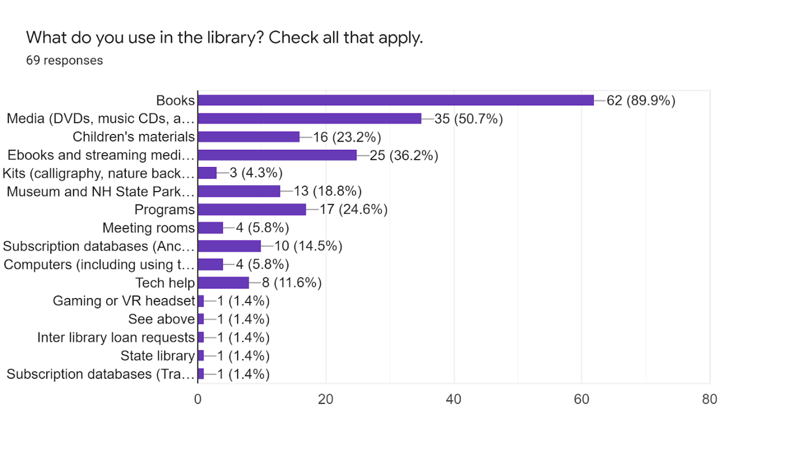

The majority of the responders use the Library a few times a year (34.2%), followed by monthly (28.8%), and weekly (21.9%). In the comments there was not a mention of the library operating hours. It appears that the operating hours work with the community at this time.

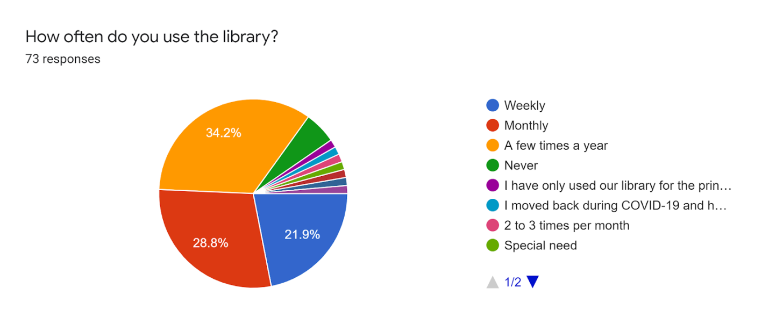

Responses showed an overwhelming preference for receiving library information electronically through social media, the town website, and the monthly email newsletter.

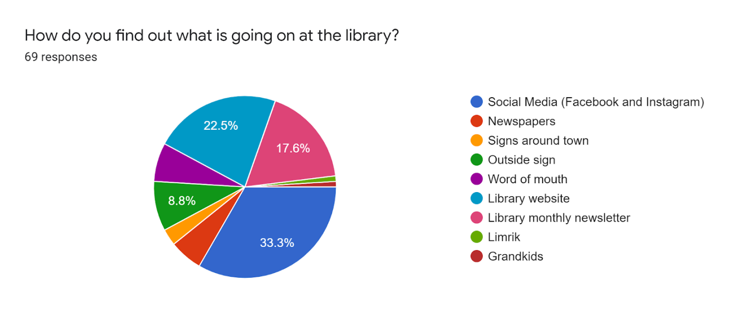

Comments:

The comment section in survey was very informative. The majority of the respondents would like the library to hold more programs. The top comment was for the library to have more adult programs followed by children’s programs, and multigenerational programs. The programs suggested were for birding, crafting, dance, gardening, tutoring, themed parties like a Gatsby party, film series, STEAM classes, and more activities for adults.

Focus group:
The focus group was held on Thursday, June 24, 2021 at 6:30 and ended at 8:00. A cross section of the community came to the library that night to let us know how they use the library and to respond to what they wanted from the library in the next five years. We found that the participants use the library in a variety of ways. For example, some use the library to support their home school curriculum; others use it for interlibrary loans, some for checking out books only, and some for our electronic offerings. Some comments and suggestions were we should keep up with maintaining the structure of the library, and have more programs. Programs were again the top request from our focus group.

Goals and Objectives:
Goal 1: Building
- The library will continue to maintain a pleasant and safe facility.
- The library will provide opportunities to bring together the community.
- The trustees and staff will be proactive on all physical maintenance issues.

Goal 2: Collection
- The library will collect items to build a library of things (items for families to check out and use together).
- The library will promote new acquisitions.
- The library will organize the collection that is easy to use for the community.
- Build and implement a comprehensive marketing plan to promote the library events, resources, services, and hours.
Goal 3: Community Engagement
- The library will partner with local schools and home school families to anticipate projects or initiatives for which additional resources may be needed or available.
- The library will partner with local organizations to provide joint programming
- Use of the Smart TV to display upcoming library events.

Goal 4: Staff
- The library will provide time for staff for professional training.
- The library will endeavor to provide an atmosphere in which staff finds work fulfilling.
- The director will set personal staff goals and the staff will receive timely annual evaluations.

References:
Antrim Historical Society. (1977). Parades and promenades. NH: Courier Printing Company.
New Hampshire Employment Security. (2021, June 2). Antrim. Retrieved from https://www.nhes.nh.gov/elmi/products/cp/profiles-htm/antrim.htm
Town of Antrim. (2021). The Antrim Community. Retrieved from https://www.antrimnh.org/antrim-community

