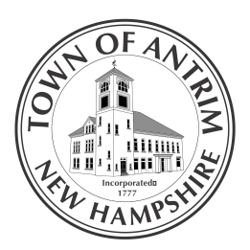
Town of Antrim
66 Main Street PO Box 517
Antrim, NH 03440
Tel: 603.588.6785 Fax: 603.588.2969
www.antrimnh.org

ANTRIM ZONING BOARD OF ADJUSTMENT

NOTICE OF PUBLIC HEARING
FEBRUARY 8, 2022

Notice is hereby given that the Antrim Zoning Board will hold a Public Hearing on Tuesday, February 8, 2022 at 7:00 PM at Antrim Town Hall to present the following request;

Clifford Thornberry & Noel Bryant, Case # 2021-07 continued, are requesting Variances from Article XI-Section Q and Article X- Steep Slope District in order to rebuild an existing non-conforming dwelling, improve driveway access, construct a new garage and review soil and slope issues within the Shoreland Protection District for property located at 15 Hillside Drive, Antrim NH 03440, Tax Map 214 Lot 055 in the Lake Front Residential District.

All are invited to appear in person or by agent or counsel to state reasons why this request should or should not be granted. Wearing masks and social distancing in the Town Hall are to be considered to minimize health issues.These hearings will be on Zoom for audio only, with log on information posted on the agenda on the Towns Website. Written concerns are to be sent to the Antrim Town Hall office prior to the meeting by mail, personal delivery or email at antrimplan2@tds.net. The applications and supporting documents are available for review at the Antrim Town Office Monday through Thursday 8:00 am to 4:00 pm.

D Scott Osgood
Antrim Town Planner
(603) 588-6785 ext. 227
Email: antrimplan2@tds.net

